

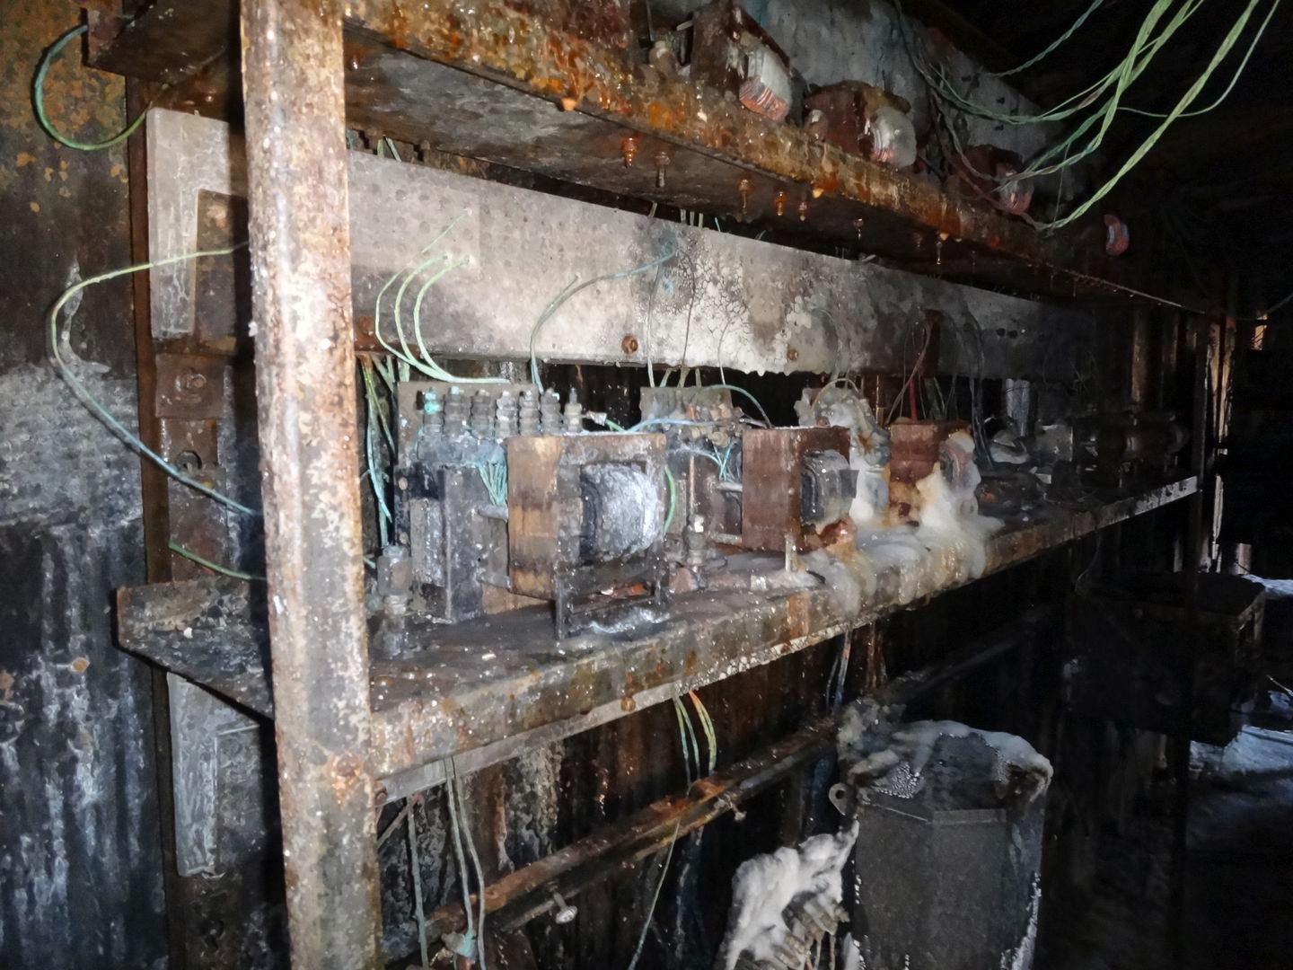

**Signal problems at Forest Hills could take**

**months to fix**

**By Aneri Pattani** Globe Correspondent, April 8, 2015, 9:15 a.m.

**6**

Lightning strike damaged an Amtrak signal system at Forest Hills station on Saturday.

Damaged Amtrak signal systems at the Forest Hills Station, which have caused commuter rail delays this week, could take months to repair completely, Amtrak officials said. But officials for the MBTA’s commuter rail operator said Wednesday that the delays could be resolved much sooner.

“We anticipate the delays passengers have been experiencing will be resolved in the next day or two as signals are restored,” said Keolis Commuter Services spokeswoman Leslie Aun. “We will be talking to Amtrak to see if the restoration schedule can be expedited, as we know this is causing our passengers a great deal of inconvenience.”

Restoration work is expected through the summer and into the fall, Amtrak spokeswoman Christina Leeds said.

Advertisement



**Quote how you want to**

Ad By Progressive See More

“Lots of specialized work and unique material is needed to complete the project,” Leeds said. “It’s not just something you can go to a store and buy, so it takes longer.”

Leeds referred questions about when MBTA commuter rail delays will end to Keolis, which operates commuter rail under contract with the public transit agency.

**Get Today's Headlines in your inbox** Enter Email

[example@email.com](mailto:example@email.com)

**Sign Up**

The day's top stories delivered every morning.

The news came as commuter rail delays continued Wednesday, **Related**

with trains on the Needham and Providence/Stoughton lines

running as much as 30 minutes late due to signal issues, according to the MBTA service alerts website.

**Commuter rail delayed after lightning damages signal system**

While inbound Providence/Stoughton line trains continued to bypass Ruggles Station Wednesday, Keolis said service would be partially restored to the station Thursday.

“Service was temporarily suspended to and from Ruggles after a lightning strike on April 4 destroyed key switch and signal equipment nearby,” Keolis spokesman Mac Daniel said. “Seven of the 10 trains that currently service Ruggles will be restored. More trains could be added at a later date.”

In a statement, Amtrak said it will “coordinate with the MBTA to provide regular updates as the project progresses.”

[Aneri Pattani can be reached at aneri.pattani@globe.com.](mailto:AneriPattanicanbereachedataneri.pattani@globe.com)

Advertisement

**Show comments**

**BOSTON GLOBE VIDEO**

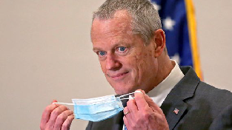

2:23

Baker announces ‘VaxMillions’ lottery program SHARE

Governor Charlie Baker announced residents who are fully vaccinated against COVID-19 will have the chance to win $1 million in a special Lottery sweepstakes. (Photo by Matt Stone/Boston Herald via AP)

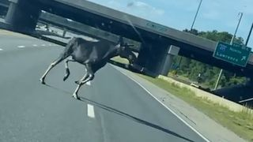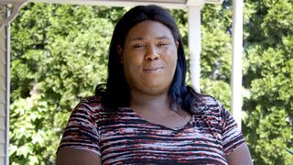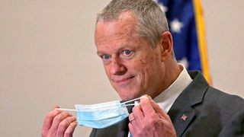

**Baker announces ‘VaxMillions’ lottery program**

**NOW PLAYING**

**Moose spotted on Route 3 in Chelmsford**

**What Black liberation means to me: Athena Vaughn**

SEE MORE VIDEOS

**MOST POPULAR ON BOSTONGLOBE.COM**

1. Life sciences is poised to be Boston’s dominant industry. Has the area become the Silicon Valley of biotech?
2. Some lawmakers want to ban critical race theory in schools. So, what is it?
3. Is there something wrong with the air in South Portland, Maine?
4. Message in a bottle, tossed into the sea in Rhode Island, found in Azores
5. How Massachusetts communities are celebrating the state’s first official Juneteenth
6. UMass Lowell to remain closed Wednesday while investigating ‘cybersecurity incident’
7. Death penalty should be reinstated for Tsarnaev in Boston Marathon bombings case, Biden administration tells Supreme Court
8. Baker announces ‘VaxMillions’ lottery program, offering $1 million cash prizes to boost vaccination rates
9. Coolidge Corner Theatre gets go-ahead for major expansion
10. A treasure map for an American tyrant



**VIEWS FROM OUR COLUMNISTS**

**YVONNE ABRAHAM**

Energy efficiency is a low-hanging fruit to combat climate change. So why can’t everyone get access to it?

**KEVIN CULLEN**

Bill Bratton on American policing and the challenge facing the Boston Police Department

**THOMAS FARRAGHER**

A salute across the ages to an old squad leader

**SHIRLEY LEUNG**

A working mother’s manifesto: Pandemic provides a once-in-a-generation chance to course correct how we work

**JENEÉ OSTERHELDT**

The pride I carry with me: Karim

**ADRIAN WALKER**

‘The best Boston movie no one’s ever seen’: ‘Blue Hill Avenue’ at 20

**MORE ON GLOBE.COM**

# SPONSORED BY: SUB- ZERO, WOLF, AND COVE

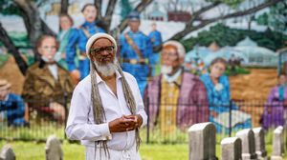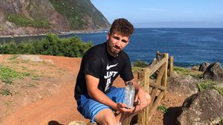

## Designing your ideal kitchen? Start with this guide.

Selecting the right high-end appliances is the secret to a luxurious space that stands the test of time.

# INNOVATION ECONOMY

## Life sciences is poised to be Boston’s dominant industry. Has the area become the Silicon Valley of biotech?

Since December, you can find six major indications that Boston is the undisputed center of the life sciences industry, a place where ideas and products that change — and save — people’s lives around the world originate.

# THE GREAT DIVIDE

## Some lawmakers want to ban critical race theory in schools. So, what is it?

As national debate over race-related curriculums rages on, here is a lesson on the subject and the controversy surrounding it.

# GLOBE MAGAZINE

## Is there something wrong with the air in South Portland, Maine?

Residents have lived near more than 100 massive petroleum storage tanks for decades, never really knowing if they’re breathing in dangerous chemicals. Now they’re fighting to find out.

## How Massachusetts communities are celebrating the state’s first official Juneteenth

For more than a century, Juneteenth was a Texan holiday, then a Southern holiday, commemorating the anniversary of June 19, 1865, when General Gordon Granger of the Union Army told formerly enslaved people in Galveston they were free. Now it will be celebrated for the first time across the Commonwealth as an official state holiday.

# RI NEWS

## Message in a bottle, tossed into the sea in Rhode Island, found in Azores

The note was written in 2018 by a 13- year-old who was visiting family in Rhode Island.

## A treasure map for an American tyrant

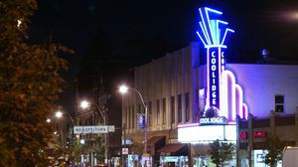

Donald Trump exposed weaknesses that a would-be dictator could exploit to end our democracy. It’s now up to lawmakers, voters, and public officials to prevent that from happening.

# PATRIOTS

## 12 observations from Patriots minicamp, day 2: Mac Jones impresses among QBs, Jalen Mills stands out

Cam Newton was 9 of 17 with one pick

— a nifty sideline theft by Kyle Dugger, who continues to show outstanding range.

## Coolidge Corner Theatre gets go-ahead for major expansion

Brookline officials are reviewing a proposed expansion of the landmark Art Deco cinema that will add two new screens — and over 200 seats — as well as a larger lobby and third-floor community space, with a catering kitchen and outdoor roof deck.

# OPINION

## I got the Johnson & Johnson vaccine. The pause makes me believe in it more.

The worst thing that could happen now is for the recommendation by the FDA and CDC to pause the vaccine’s administration to spur a new wave of vaccine hesitancy.

### MOST READ IN THIS SECTION

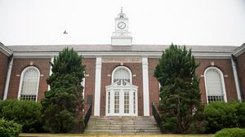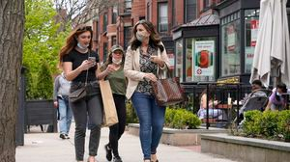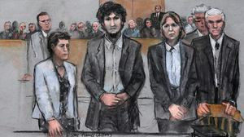

**THE GREAT DIVIDE**

**Some lawmakers want to ban critical race theory in schools. So, what is it?**

**GLOBE MAGAZINE**

**Is there something wrong with the air in South Portland, Maine?**

**How Massachusetts communities are celebrating the state’s first official Juneteenth**

**RI NEWS**

**Message in a bottle, tossed into the sea in Rhode Island, found in Azores**

**UMass Lowell to remain closed Wednesday while investigating ‘cybersecurity incident’**

**The downside of ditching masks: the return of colds, flu**

**Death penalty should be reinstated for Tsarnaev in Boston Marathon bombings case, Biden administration tells Supreme Court**

**Baker announces ‘VaxMillions’ lottery program, offering $1 million cash prizes to boost vaccination rates**

**FOLLOW US**

### SUBSCRIBE NOW MY ACCOUNT CONTACT MORE

Digital Access / Home Delivery / Gift Subscriptions

Log In /

Manage My Account / Customer Service

Help & FAQs / Globe Newsroom / Advertise

Newsletters / View The EPaper /

Order Back Issues / News In Education / Search The Archives / Privacy Policy / Terms Of Service / Terms Of Purchase / Work At Boston Globe Media /

Do Not Sell My Personal Information

**METRO SPORTS BUSINESS & TECH OPINION**

WELCOME, JOHN

**TODAY'S PAPER**

**Summer Fitness Challenge Starts Monday**

Sign up now

©2021 Boston Globe Media Partners, LLC